Microsoft Office Home Use
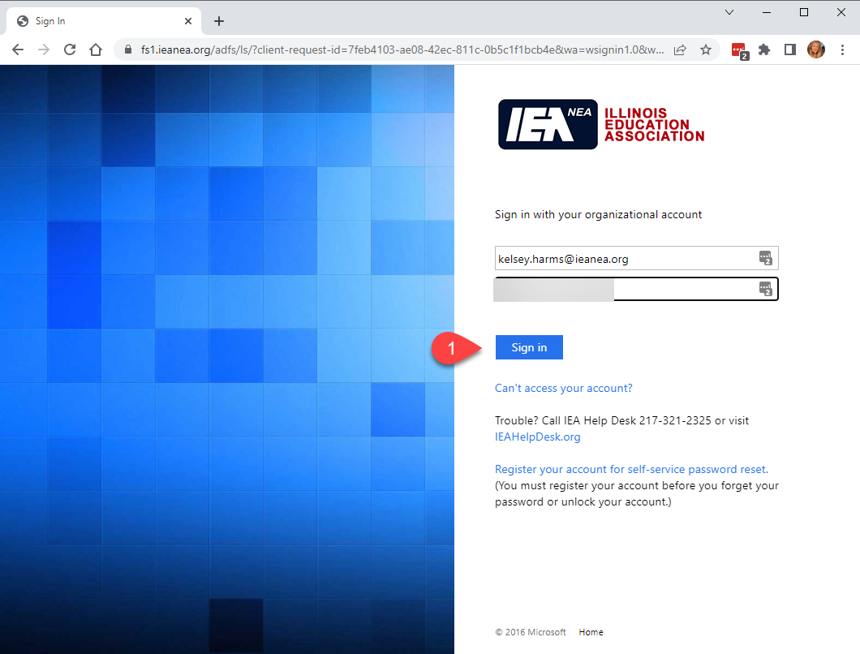
With our Office365 agreement you can install the Office apps on up to 5 devices while you are employed by IEA. NOTE: One of your 5 devices is your IEA computer – DO NOT INSTALL THIS SOFTWARE ON YOUR IEA ISSUED COMPUTER. You should use OWA to access your email from your non-IEA issued computers. Computer Services WILL NOT assist you in setting up Outlook or help setup Office on your non-IEA issued computer. We will assist you in accessing the portal.
- To install the software, go to portal.office.com and sign in with your IEA email address and password.

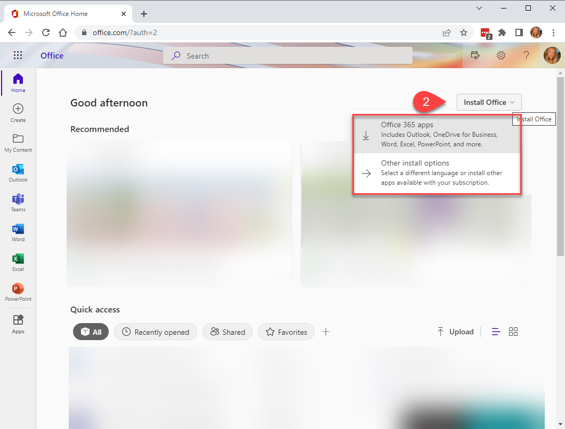

- You should be directed to this page that will allow you to download and install office on your personal computer.
NOTE: You can install this software on a Mac under Other install options.

